About Canine Companion Club
Canine Companion Club, located in the Columbus, Ohio area, is a private off-leash dog park in a unique country setting on 11 spacious acres of maintained grounds with majestic pine trees with a two acre beautifully maintained "Golden Pond". Their purpose is to create a natural, safe, and healthy controlled environment for all their guests. Your dog has the option of swimming, playing ball or simply running free enjoying the great outdoors all in a fully fenced secured area.
About Humane Society of Delaware County
Founded in 1972, The Humane Society of Delaware County’s shelter has recently averaged about 1,400 adoptions per year, with added programs such as a low-cost, spay and neuter clinic, cruelty investigations and humane education. The dedicated staff and volunteers have achieved great success in recent months by placing animals with special needs or disabilities in safe and loving forever homes - something very rare in shelter situations.


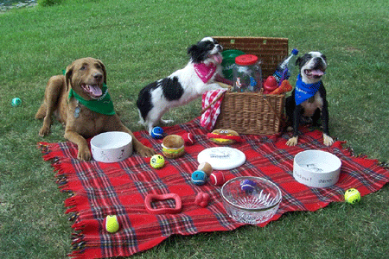





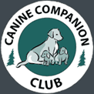
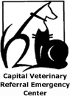Pooper Troopers

1st Annual
Picnic with the Pups
Saturday, August 27, 2005
10 – 5 PM EST
6306 Home Rd, Delaware, OH
Fundraiser Benefiting Community Rescue Groups
Grr-eat food, grr-eat music, grr-eat cause!
Hosted by

Canine Companion Club, LLC
Humane Society of
Delaware County

WELCOME TO OUR 1ST ANNUAL PICNIC WITH THE PUPS!
Picnic with the Pups will be an annual Canine Companion Club event designed where companion dogs and their guardians can play together on 11-acres of beautiful secure grounds with a two-acre ”Golden Pond”.
In addition to great food, drink, live music and prize giveaways, our goal is to help promote awareness of the growing number of homeless pets and the dedicated staff and volunteers of various rescue organizations who work to find them safe and loving, forever homes.
On behalf of Picnic with the Pups, we encourage you to support our community rescue groups, shelters, vendors and sponsors who helped make this year’s event fun-filled for you and your companion pet!

Visit OUR NEW UPSCALE DOGGY DAY CARE!
Beginning at 11 AM EST, join Marshall McPeek of NBC Channel 4 in the ribbon cutting ceremony of our new upscale Doggy Day Care. The event will also include a Certificate of Recognition from Mayor Michael Coleman.

saTISFY your appetite!
Beginning at 12 PM EST, bring your four-legged best friend and join us in front of the Wise’s residence for a cooling soft drink and delicious “grab and go” boxed lunch with dessert compliments of Patrick J’s Grille and Visions Catering.
Beginning at 2 PM EST, kick back, relax and listen to the smooth sounds provided by Standard Time Jazz Trio!

INDULGE IN biscuit and wine tasting!
While listening to live jazz music, adults 21 years of age or older can sample two great wines from the vineyards of Dog House Winery in Santa Rosa, CA:
- 2004 Chardonnay (a youthful, playful, fruit-driven wine with refreshing aromas of juicy lemon and sweet citrus blossom)
- 2002 Merlot (eager to please with a friendly nose of sweet black cherries, strawberries and the perfume of iris blossoms)
To compliment your wine tasting experience, an assortment of tasty biscuits will be made available for your companion pet, compliments of PetSMart, Iams and Eukanuba.

two paws up!
A HUGE “Thanks” to our vendors…
- Acme Canine
- American Express Financial Advisors
- Animal Hospital of Polaris (microchipping)
- Classy Canine Cuts
- Cuccia Creative Illustrations
- Delicious Dog Treats by Julie
- Fundogmentals
- Horse and Dog Portraits by Jennifer Lyon
- Jake & Emma’s Pet Place
- Left Bank Pawtisserie
- My Goodies Modeling Agency
- New Day New Dog Training
- SL Embroidery
- The Pampered Paw
- Two Dog Studio

…And rescue groups:
- Animal Rescuer’s Friend (Paw Wash)
- Bigdoghouse Great Pyrenees Rescue
- Cause for Pause Rescue
- Central Ohio Westie Rescue
- Franklin County Dog Shelter/Friends of the Shelter
- Golden Endings
- Humane Society of Delaware County
- Heart of Ohio Boxer Rescue
- Lil Paws Rescue
- Lucky Chin Adoptions
- Ohio Pug Rescue
- Second Chances Dalmatian Rescue
- Tender Loving Canine Rescue
- Tri-State Collie Rescue

